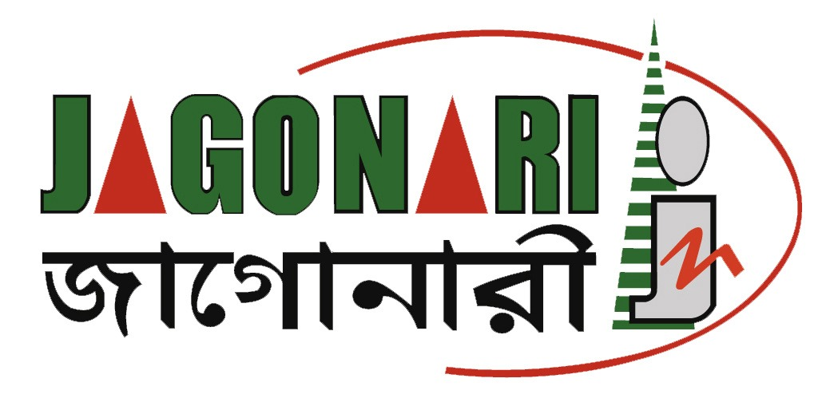

Photo

Job Application Form_JN001
(Please fill out the parts related to you, otherwise mention N/A. All information will be treated confidentially)

Name of applicant:
Contact number:
Email ID:

Name of Position applied for
Project’s name

- Personal information

Applicant name
Father’s name
Mother’s name
Permanent address
Present address
Religion
Date of birth
Sex
Marital status
Nationality
NID card no.
Driving license no.
Blood Group

- Academic Qualification

Examination | Board/University | Passing year | Result | Major subject

- Describe how you fit for the position focusing relevant experience (Maximum 250 words)

- Present Job experience (If applicable)

Name of Organization
Position
Project’s Name
Project’s Location
Job duration | From: | To: | Job duration:
Major Responsibilities (short sentence and key word)

- Professional Experience, please start from most recent. (May be inserted same boxes as below like Job: F, Job: G or more if required/you can also delete if not required)

Job: A

Name of Organization
Position
Project’s Name
Project’s Location
Job duration | From: | To: | Job duration:
Major Responsibilities (short sentence and key word)

Job: B

Name of Organization
Position
Project’s Name
Project’s Location
Job duration | From: | To: | Job duration:
Major Responsibilities (short sentence and key word)

Job: C

Name of Organization
Position
Project’s Name
Project’s Location
Job duration | From: | To: | Job duration:
Major Responsibilities (short sentence and key word)

Job: D

Name of Organization
Position
Project’s Name
Project’s Location
Job duration | From: | To: | Job duration:
Major Responsibilities (short sentence and key word)

Job: E

Name of Organization
Position
Project’s Name
Project’s Location
Job duration | From: | To: | Job duration:
Major Responsibilities (short sentence and key word)

- Major and relevant raining received (May be inserted more rows if needed)

Sl. no. | Name of training | Major Content | Organized by | Year | Duration
1
2
3
4
5
6
7

- Language Proficiency (Excellent/good/moderate)

Language | Reading | Writing | Speaking
Bangla
English
Any others

- Computer, online platform, internet browsing skill (Excellent/good/moderate)

MS Word | MS Excel | MS PowerPoint | Adobe Photoshop | Email & website | Mention others if any (like google meet/zoom/kobo etc.

- Driving skill (yes/no)

Motor Cycle | Valid driving Licensee | If any, mention please

- Others skills, publications and abroad experiences

Skill (if any) | Publications (if any) | Abroad experience (if any)

- Declaration of criminal records (Please write down Yes/No

Topics | Yes | No
- Do you have any criminal convictions (past or pending) of the following nature which would prevent you from working with children or vulnerable adults?
- Offences of a sexual nature including, but not limited to, rape, sexual assault or sexual harassment.
- Offences involving financial abuses including but not limited to fraud, bribery, theft etc.

If yes, please provide further details:

- References (From present and previous 1/2 organizations. One Referee from HR department of the present/immediate past organization is admirable)

1. Name, Designation, Contact number and Email ID | 2. Name, Designation, Contact number and Email ID | 3. Name, Designation, Contact number and Email ID

Certification

I certify that all information sated in the curriculum vitae is true and compete to the best of my knowledge. I authorize you to verify information provided in the curriculum vitae.

I confirm that the information provided above and, in any attachment, are correct and I understand that any false statement or information could result in my application or appointment being terminated.

Signature:

Name:
Date:

